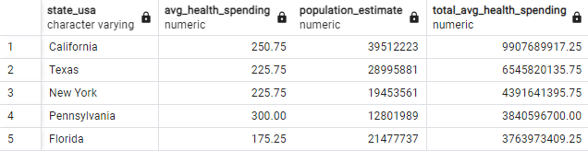
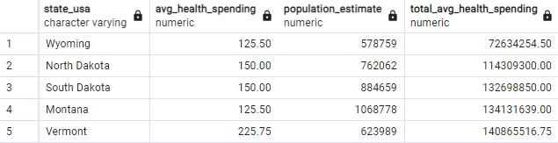

Average Competitor Profit is negatively correlated with the Min, Avg, and Max Property Prices, with the Max Property Price having the highest negative correlation.

Health Spending and Income per Capita are positively correlated with each other.

Income and Property Price are positively correlated with each other.

=> As Income/Property Price/Health Spending Increases → Average Competitor Profit Decreases, and vice-versa.

